

Rates of Chemical Reactions

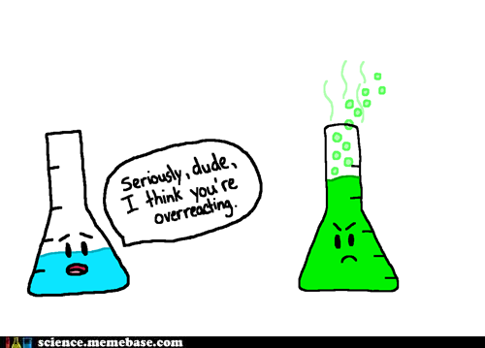

(Hellsing nd)

(HostelsClub nd)



(Niadd 2013)

|  |  |  |  |
| --- | --- | --- | --- |
| **Week** | **Outcomes** | **References** | **Tasks** |
| **20** | * the rate of chemical reactions can be quantified by measuring the rate of formation of products or the depletion of reactants * the activation energy is the minimum energy required for a chemical reaction to occur and is related to the strength and number of the existing chemical bonds; the magnitude of the activation energy influences the rate of a chemical reaction * energy profile diagrams, which can include the transition state and catalysed and uncatalysed pathways, can be used to represent the enthalpy changes and activation energy associated with a chemical reaction * varying the conditions under which chemical reactions occur can affect the rate of the reaction | Lucarelli p113 Set 23 (p119) q1-14 |  |
| **21** | * varying the conditions under which chemical reactions occur can affect the rate of the reaction * collision theory can be used to explain and predict the effects of concentration, temperature, pressure, the presence of catalysts and surface area on the rate of chemical reactions * catalysts, including enzymes and metal nanoparticles, affect the rate of certain reactions by providing an alternative reaction pathway with a reduced activation energy, hence increasing the proportion of collisions that lead to a chemical change | STAWA Experiment 39 p93  STAWA Experiment 40 p95  STAWA Experiment 41 p96 |  |
| **22** | * collision theory can be used to explain and predict the effects of concentration, temperature, pressure, the presence of catalysts and surface area on the rate of chemical reactions * catalysts, including enzymes and metal nanoparticles, affect the rate of certain reactions by providing an alternative reaction pathway with a reduced activation energy, hence increasing the proportion of collisions that lead to a chemical change |  | Task 10  Task 11 |

Davis, A. *Nelson Chemistry Units 1 & 2.* South Melbourne: Cengage Learning Australia Pty Limited, 2014.

Lucarelli, N. *ESSENTIAL CHEMISTRY Australian Curriculum for WA ATAR Chemistry Units 1 + 2.* Willetton: Lucas Publications, 2014

Clark, J and Baddock, M *Exploring Chemistry Year 11 Experiments, Investigations and Problems* Osborne Park STAWA, 2014.

### In addition the following objectives will need to be mastered in order to pass this course.

### Science Inquiry Skills

* identify, research, construct and refine questions for investigation; propose hypotheses; and predict possible outcomes
* design investigations, including the procedure(s) to be followed, the materials required, and the type and amount of primary and/or secondary data to be collected; conduct risk assessments; and consider research ethics
* conduct investigations safely, competently and methodically for the collection of valid and reliable data, including: chromatography, measuring pH, rate of reaction, identification of the products of reactions, and determination of solubilities of ionic compounds to recognise patterns in solubility
* represent data in meaningful and useful ways, including using appropriate graphic representations and correct units and symbols; organise and process data to identify trends, patterns and relationships; identify sources of random and systematic error; identify anomalous data; estimate the effect of error on measured results; and select, synthesise and use evidence to make and justify conclusions
* interpret a range of scientific and media texts, and evaluate processes, claims and conclusions by considering the quality of available evidence; and use reasoning to construct scientific arguments
* communicate to specific audiences and for specific purposes using appropriate language, nomenclature and formats, including scientific reports

Reaction rate can be measured in **two** ways.

By measuring the:

* Rate of disappearance of reactants
* Rate of appearance of products

For the following reaction, state three ways the reaction rate could be determined.

CaCO3(s) + H2SO4(aq) → CaSO4(aq) + CO2(g) + H2O(*l*)

By measuring the:

1. rate of disappearance of CaCO3(s)
2. rate of appearance of CO2(g)
3. rate of change in pH of solution

Collision theory states that in order for a reaction to occur, three criteria must be met:

* Reactant particles must collide
* Reactant particles must collide with a certain minimum energy (activation energy, E­­a)
* Reactant particles must collide with correct orientation

Draw labelled potential energy profile diagrams showing an exothermic reaction and an endothermic reaction.

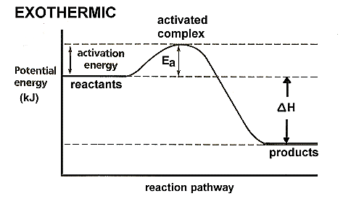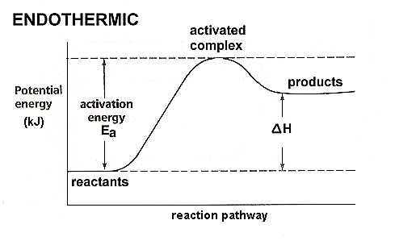

(NA, Energy Diagrams 2012)

Define the following terms:

* Enthalpy – the total energy (both chemical stored potential and kinetic energy) present in a substance.
* ∆H – change in enthalpy (Hproducts – Hreactants)
* Activation energy – the minimum energy required to reach the transition state in a reaction
* Transition state (activated complex) – highly unstable arrangement in a chemical reaction where bond breaking and forming is occurring. It is a momentary arrangement which has the highest enthalpy for the reaction.

Describe the following relationships:

* Activation energy and bond strength – in general as bond strength increases, activation energy increases as more energy is required to break the bonds.
* Activation energy and bond number – in general as bond number increases, activation energy increases as more energy is required to break the greater number of bonds.
* Activation energy and rate of reaction – in general as the activation energy increases, the rate of reaction decreases.

For each of the following factors that affect reaction rate, use collision theory to explain why the reaction rate is impacted. If possible, use an appropriate, labelled diagram to support your explanation.

* Concentration

Increasing the concentration of one or more of the reactants decreases the distance between the particles which increases the frequency/rate of collisions taking place which increases the reaction rate.

* Pressure – increasing the pressure of a gas by either reducing the volume or adding more of the same gas decreases the distance between particles which increases the frequency/rate of collisions taking place which increases the reaction rate.
* State of subdivision – increasing the surface area of one or more of the reactants (eg through grinding, atomising (spray), agitation, etc) exposes more reactant particles to each other at one time which in turn increases the frequency/rate of collisions which increases the reaction rate.
* Temperature

Increasing the temperature increases the average kinetic energy of the reactant particles.

This increases the proportion of particles that have **sufficient kinetic energy to meet the activation** energy required for a successful collision which increases the reaction rate.

To a much lesser degree, by increasing the kinetic energy of the particles, the particles move faster which increases the frequency/rate of collisions that occur which also increases the reaction rate.

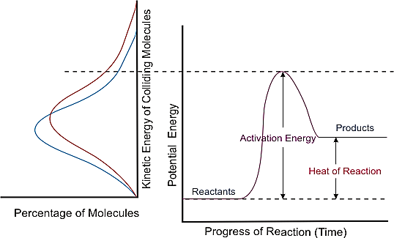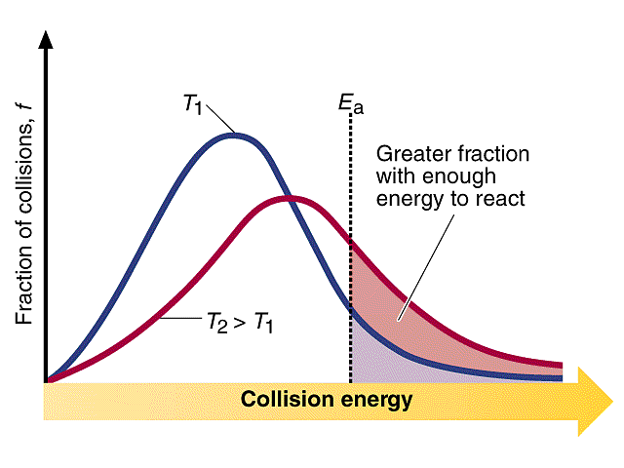

(Luetgens nd) (CDLI 2007)

* Catalysts

Catalysts speed up chemical reactions but remain chemically unchanged by the end of the reaction (ie no net consumption of the catalyst occurs).

Catalysts provide an alternate reaction pathway with a lower activation energy. This means a greater proportion of reactant particles will have sufficient kinetic energy to meet the required activation energy for a successful collision which increases the reaction rate.

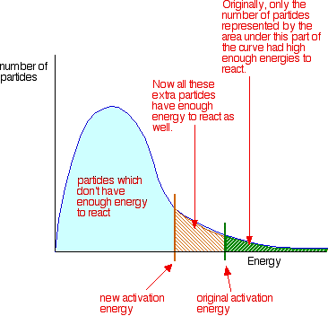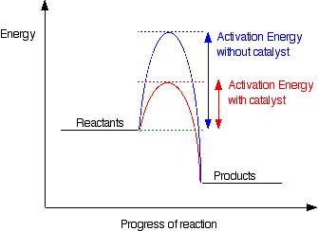

(Clark 2002)

**Enzymes: Biological Catalysts**

Define the following terms in the context of biological catalysts:

* Enzyme – a protein that acts as a specific biological catalyst.
* Substrate – the specific reagent molecule(s).
* Enzyme specificity – the ability of an enzyme to catalyse a specific reaction.
* **Lock and key model** (include a diagram) – a model used to illustrate the basic working of an enzyme. The substrate fits onto the active site on the surface of the enzyme where it is held in place by weak intermolecular forces. Whilst docked, the bond rearrangements in the substrate are more easily achieved (increasing the reaction rate). Once reacted, the substrate disengages from the enzyme.

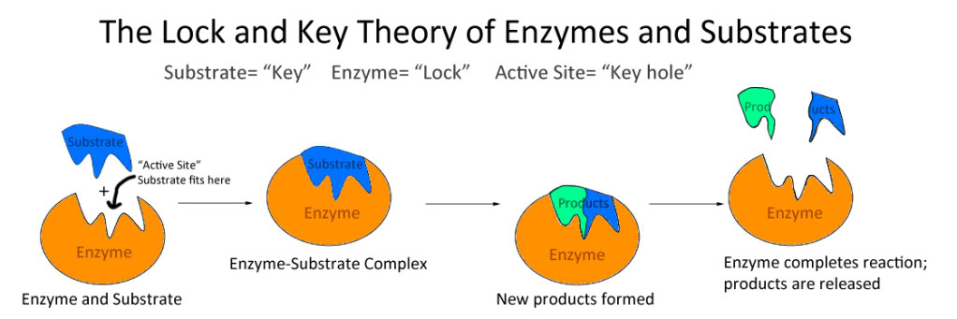

(NA, Why is an Enzyme Called a Lock and Key Model nd)

**Nanoform catalysts**

What is the main advantage of nanoform catalysts? They have a very **large surface to volume ratio.**

# Bibliography

CDLI. "Factors Affecting Reaction Rates." *CDLI.* 2007. https://www.cdli.ca/sampleResources/chem3202/unit01_org01_ilo03/b_activity.html (accessed July 8, 2015).

Clark, J. "The Effect of Catalysts on Reaction Rate." *Chemguide.* 2002. http://www.chemguide.co.uk/physical/basicrates/catalyst.html (accessed July 8, 2015).

Hellsing, Lady Integra. "Chemistry, Biology, Physics, Microbiology and All." *Pinterest.* nd. https://www.pinterest.com/martamoretti23/chemistry-biology-physics-microbiology-and-all/ (accessed July 8, 2015).

HostelsClub. "Seriously Dude, I Think You're Overreacting!" *Twitter.* nd. https://twitter.com/hostelsclub/status/350511160166060033 (accessed July 8, 2015).

Luetgens, D. "Temperature and Reaction Rate." *Explore, Experiment, Explain: Science An Excellent Adventure.* nd. http://dluetgens.com/temp_and_rxn_rate.html (accessed July 8, 2015).

—. "Energy Diagrams." *C&J&S&B's Class Chemistry.* February 1, 2012. http://chemistrywithelevens.blogspot.com.au/2012/02/energy-diagrams.html (accessed July 8, 2015).

—. "Why is an Enzyme Called a Lock and Key Model." *Answers.* nd. http://www.answers.com/Q/Why_is_an_enzyme_called_lock_and_key_model (accessed July 8, 2015).

Niadd. "Ten Wallpaper." *Club Catalyst.* June 27, 2013. http://www.niadd.com/pictures/funny/2317243.html (accessed July 8, 2015).